Q.1 Write two different queries that would produce all orders taken on october 3rd or 4th 1990.
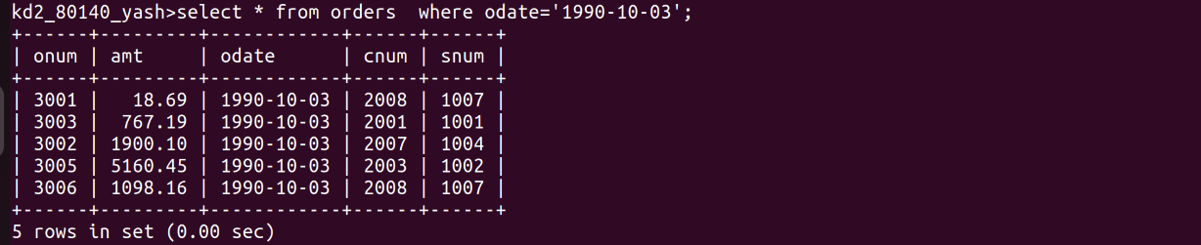
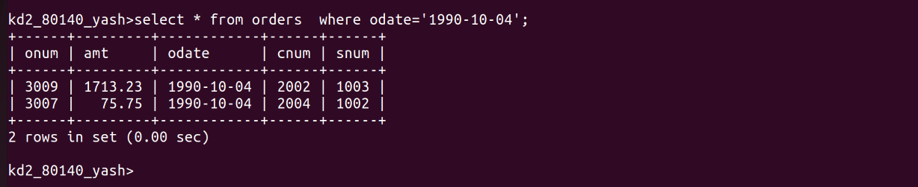
Q.2 Write a query that selects all of customers serviced by Peel or Motika.
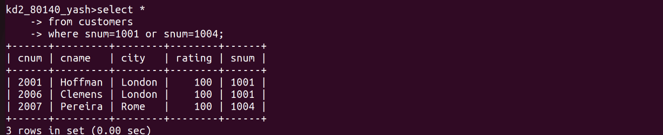
Q.3 Write a query that will produce all the customers whose begin with a letter from ‘A’ to ‘G’
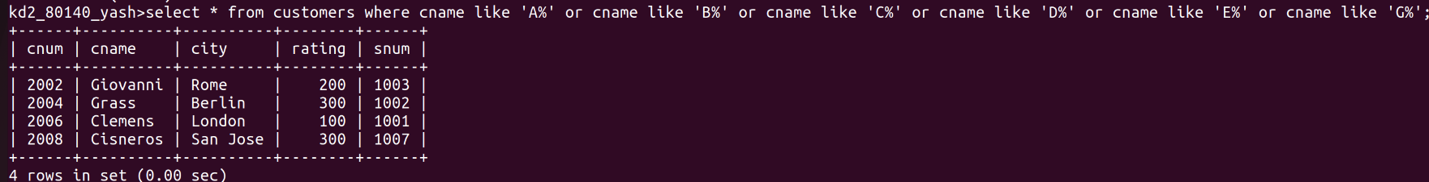
Q.4 Write a query that selects all customers whose names begin with the letter ‘C’

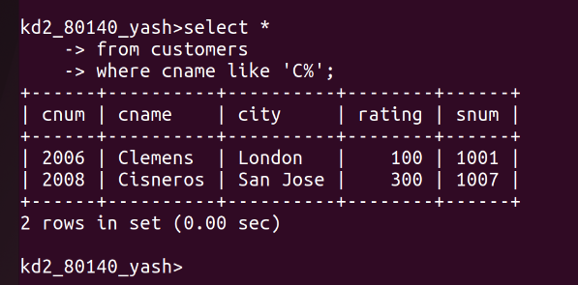
Q.5 Write a query that selects all orders except those with zeroes or null in the amt field.

